The goal is to calculate experienced inflation of each individual i.
Preparation: dataset.
Data_cleaned.xlsx:
Panelid: comes from raw data of JHPS-CPS, from 2004 to 2024.
Year and CCPI: each year’s core CPI.
Birth_fixed: comes from raw data of JHPS-CPS, birth year of each individual i.

Experienced inflation.py: Based on data_cleaned.xlsx, calculate experienced inflation of each individual i in year t.

Equation:
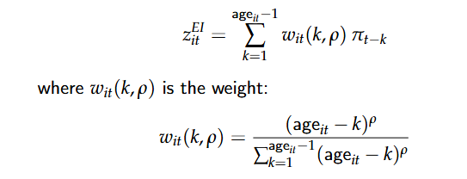
Following Mineyama and Tokuoka (2025), estimated $ρ=11.03$.

